# Informações do estudo

Referência: Laouissi (CC1690)

Grandeza: Força

Tipo: Fz

Material: EN-GJL-250 cast iron

Ferramenta: CC1690

Número de experimentos: 27

Observações:  
Workpiece: 80mm in diameter and 400mm in length  
Lathe: TOS TRENCIN-SN40C  
Dynanometer: KISTLER  
Tool holder: CSDNN25x25M12  
Roughness meter: Mitutoyo surftest-201

# Unidades

Velocidade: m/min

Avanço: mm/rev

Profundidade de corte: mm

Força: N

# Dados de teste

|  |  |  |  |
| --- | --- | --- | --- |
| Força | n | f | a |
| 45.58 | 260.0 | 0.08 | 0.25 |
| 246.17 | 260.0 | 0.14 | 0.75 |
| 143.5 | 370.0 | 0.14 | 0.5 |
| 153.68 | 260.0 | 0.14 | 0.5 |
| 76.58 | 530.0 | 0.2 | 0.25 |
| 115.93 | 260.0 | 0.08 | 0.5 |

# Dados de treino

|  |  |  |  |
| --- | --- | --- | --- |
| Força | n | f | a |
| 239.2 | 370.0 | 0.14 | 0.75 |
| 137.73 | 530.0 | 0.08 | 0.75 |
| 173.4 | 530.0 | 0.2 | 0.75 |
| 183.86 | 370.0 | 0.2 | 0.5 |
| 151.26 | 260.0 | 0.08 | 0.75 |
| 43.74 | 370.0 | 0.08 | 0.25 |
| 107.14 | 260.0 | 0.2 | 0.25 |
| 307.2 | 260.0 | 0.2 | 0.75 |
| 255.12 | 370.0 | 0.2 | 0.75 |
| 84.48 | 530.0 | 0.08 | 0.5 |
| 82.06 | 370.0 | 0.2 | 0.25 |
| 75.23 | 370.0 | 0.14 | 0.25 |
| 171.16 | 530.0 | 0.2 | 0.5 |
| 90.07 | 370.0 | 0.08 | 0.5 |
| 82.31 | 260.0 | 0.14 | 0.25 |
| 221.69 | 530.0 | 0.14 | 0.75 |
| 61.88 | 530.0 | 0.14 | 0.25 |
| 30.73 | 530.0 | 0.08 | 0.25 |
| 206.42 | 260.0 | 0.2 | 0.5 |
| 146.71 | 370.0 | 0.08 | 0.75 |
| 133.8 | 530.0 | 0.14 | 0.5 |

# RN

Número de neurônios: 95

Taxa de aprendizado: 1.000000e-04

Número de épocas: 984

2° camada: True

Função de ativação: relu

# Erros

**Dados de teste**

* Erro relativo médio: 12.23
* Coeficiente de correlação: 0.98
* Coeficiente de determinação: 0.96
* MSE: 229.04
* RMSE: 15.13

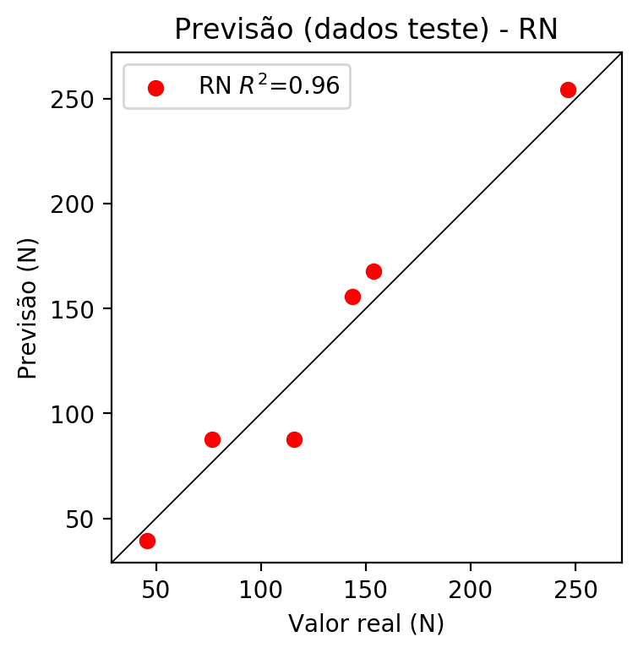

**Dados de treino**

* Erro relativo médio: 1.51
* Coeficiente de correlação: 1.0
* Coeficiente de determinação: 1.0
* MSE: 17.32
* RMSE: 4.16

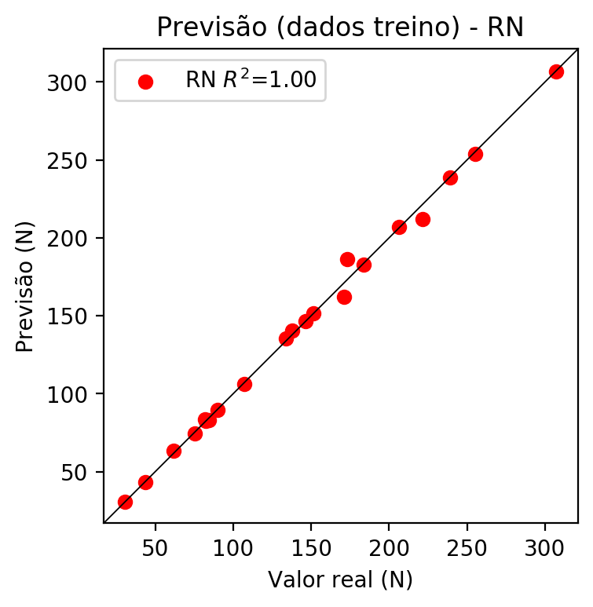

# Pesos

Pesos - camada oculta 1

[[ 0.15123126 0.08051782 -0.1483636 0.0063509 0.16798806 -0.14342538  
 -0.064082 0.04353565 -0.08618999 0.0512709 -0.26768124 0.16755407  
 0.0561337 -0.00909866 -0.1318152 -0.05910874 0.04816283 -0.08389556  
 -0.24560429 0.17833771 0.22730425 0.20398673 -0.02392472 0.14279377  
 -0.0513631 -0.19698347 0.27913615 0.03795585 0.21389915 -0.2064214  
 -0.07359079 -0.2998012 -0.14769371 -0.23465914 -0.02479206 -0.15486875  
 0.05575607 0.10703354 -0.21456885 -0.08944979 0.13655747 0.10825204  
 0.20109138 0.22372612 0.1115256 -0.00932027 0.03103151 -0.1575458  
 0.2063622 0.23686759 0.150195 0.13649595 0.07845039 -0.08541095  
 -0.11992874 0.07632019 0.02874095 0.01127141 -0.2530725 -0.2160957  
 0.22107077 -0.18507102 -0.2576378 0.06287086 0.24653673 -0.2620294  
 -0.02000212 0.09924319 -0.19407718 -0.11617195 -0.05270195 0.02501261  
 -0.02056411 -0.18559974 0.09791332 -0.16874968 0.05738871 0.20950677  
 0.03825978 -0.04679273 0.15598719 -0.2279014 -0.22404797 -0.05892722  
 -0.14886394 0.19180487 0.02170065 -0.2042597 -0.22077069 0.21743083  
 -0.10140099 -0.19635318 -0.26403382 0.04261776 -0.04832316]  
 [-0.15526167 -0.26814952 0.05179938 0.10932826 -0.18705462 0.13500512  
 -0.11558652 0.20929031 -0.16743535 -0.24447183 -0.16825522 -0.08436675  
 -0.11965082 0.02597553 0.17899589 -0.01928191 -0.14101894 0.23309384  
 0.21992044 0.05848019 0.23204882 0.05168775 -0.07887167 -0.06690285  
 -0.13139439 0.06570874 -0.17452472 0.02657787 -0.06322623 0.2376333  
 0.03175872 0.20086126 -0.04484612 -0.17618 -0.08610129 0.12691002  
 0.00150709 0.02500826 0.0906022 0.19262308 0.15734929 -0.10341609  
 0.10059151 -0.22787783 0.21483825 -0.11976659 -0.25418305 0.03425077  
 -0.02889166 -0.00632331 -0.07098532 0.26079834 0.12982231 0.19809142  
 0.05618804 0.24017069 -0.2191335 0.01501515 -0.13466795 -0.1815174  
 -0.21990147 0.17296767 0.1872211 0.13045055 -0.06142221 -0.12980467  
 0.19554636 -0.20876215 -0.03778934 -0.17702283 -0.20671137 0.19294344  
 -0.09138134 -0.20710777 -0.08750632 -0.08286238 0.15301533 -0.23716366  
 0.17522322 -0.25282574 0.11240702 -0.25859806 0.13665959 0.05320817  
 -0.22552925 0.25704774 0.14790744 0.1157655 -0.09144199 -0.08189327  
 -0.10359627 0.2141689 0.23711674 -0.0278151 -0.12054808]  
 [ 0.00795659 -0.16203323 -0.13645759 0.05267084 0.08654299 -0.0785102  
 0.18515018 0.13276313 -0.10750983 -0.04304045 0.20720264 -0.24312755  
 0.25456434 0.05802166 -0.06730127 -0.11611444 -0.07883959 -0.03743101  
 0.01320606 0.188348 0.02900814 -0.08461597 -0.21048935 0.12761207  
 0.1425344 0.08738097 0.08886468 0.14055748 0.2206877 0.11799189  
 0.17706716 0.11845574 -0.11413916 0.1594938 0.15568487 -0.12979802  
 -0.04167477 -0.12460182 0.11112691 -0.21929252 -0.24601026 -0.10979012  
 -0.06653245 -0.22879867 0.22314973 0.11788619 -0.10582607 -0.11244835  
 0.24881512 -0.12427594 0.07910743 -0.04608879 0.10532217 -0.04785812  
 0.0807023 0.18746255 -0.0040442 -0.01011381 0.05934737 0.01081503  
 0.1576584 -0.14878088 0.23133624 -0.12813534 0.1008189 0.14802402  
 0.22120596 0.05075512 0.1163422 -0.18407649 -0.16053288 0.22237545  
 -0.01490171 -0.12971136 -0.18437189 -0.0407654 -0.05416616 -0.13411468  
 -0.20773607 0.04179938 0.06588225 0.03462064 -0.19335333 -0.25930882  
 -0.05749335 0.04296863 0.06842236 -0.06069066 -0.12434389 -0.06752  
 -0.00507224 0.224096 -0.19787192 -0.11703771 0.03634 ]]

Bias - camada oculta

[-0.01483032 0.02410971 -0.01318691 0.03079219 0.02223179 0.01969732  
 0.01676566 0.02905241 0.00889922 -0.01334197 0.02207673 0.0166078  
 0.02636529 -0.01959996 0.03299484 0.02745988 -0.01233914 0.0216172  
 0.03132542 0.01806157 -0.01335603 0.02535569 0.02094196 0.03128132  
 0.05179258 0.01919585 0.01986129 0.03593796 0.03979706 0.02076351  
 0.02218952 0.00027792 0.02022873 0.04197238 0.02006648 -0.01413316  
 0.01377195 0.01395674 0.02938806 0.01024229 0.02341328 -0.01338468  
 0.02437485 -0.00888039 0.03326945 -0.00102849 0.02037629 0.01316644  
 0.03604263 0.01991447 0.00481421 0.01410323 0.02704013 0.01764447  
 -0.01348601 0.03025881 0.00763807 -0.01133109 0.02633026 -0.00133087  
 0.00242393 -0.01125369 0.01399928 -0.00899158 0.00053575 0.0267912  
 0.02937019 0.00922085 -0.0079416 0.02301866 -0.00278879 0.03444226  
 -0.00649491 -0.00868154 0.01120002 0.01219285 0.01071205 0.01238344  
 -0.00942048 0.00911895 0.01940785 -0.01531548 -0.01316306 0.01080836  
 -0.00274186 0.02914849 -0.01776222 -0.01320127 0.01350554 0.01445145  
 -0.00886467 0.02818937 0.01814019 -0.01105174 0.01763911]

Pesos - camada oculta 2

[[ 0.10538227 0.08141679 -0.11019299 ... -0.14929774 0.05360166  
 -0.0466853 ]  
 [-0.13888368 -0.2279597 0.06361455 ... 0.1764623 -0.03501557  
 -0.04120632]  
 [-0.0127532 -0.14835696 -0.04854377 ... -0.10981159 -0.1120462  
 0.06954599]  
 ...  
 [ 0.03570467 0.08272652 0.07182432 ... 0.10850487 0.12019751  
 0.15407328]  
 [-0.19258758 -0.16255653 -0.06306852 ... -0.07053857 -0.0412807  
 0.1422613 ]  
 [-0.0806098 0.06584685 0.02205672 ... 0.13036124 -0.02971348  
 0.03676785]]

Bias - camada oculta 2

[ 0.03083398 0.0215789 0.01139017 -0.00561622 -0.00785907 0.00447627  
 -0.00914261 0.01713084 0.01375362 0.00644371 0.01646873 0.02511887  
 0.00583503 0.00403967 0.01462854 0.02227703 0.02765148 -0.03575711  
 -0.01808828 0.00628431 0.01052359 0.01663483 0.01753779 -0.00921017  
 0.01164652 0.01339319 0.02966439 -0.00430857 -0.00442257 0.01577461  
 -0.00885428 -0.00405201 0.00682387 -0.01638197 0.02695502 -0.00580226  
 0.03103831 -0.01064221 0.01409812 0.0192233 0.0307493 -0.01127452  
 -0.00369993 0.01631172 -0.01287148 -0.00432615 0.04262113 0.01377663  
 0.02694103 0.03262844 0.02630963 0.02213368 -0.00500327 0.0173084  
 -0.01892514 -0.01381284 0.01415409 0.02948742 -0.00255846 0.01431962  
 0.03369787 0.00415435 0.0162539 -0.00173833 -0.0068391 -0.00669927  
 0.02233789 0.02725755 0.01289311 0.01308984 0.02469255 0.  
 -0.0344583 -0.00430545 0.02341261 0.01567574 -0.00285097 0.02397322  
 0.02550622 -0.01237927 0.02922568 -0.00919273 -0.00576022 0.01610832  
 0. 0.02604675 0.02075353 0.0100263 -0.00931852 0.03449649  
 0.01656563 -0.0249479 0.02438547 0.04366832 0.01360629]

Pesos - camada saída

[[ 0.18890214 0.076378 -0.19189057 0.0365928 0.13540432 -0.12946133  
 -0.05074384 0.02288118 -0.10732057 0.08978973 -0.27010113 0.22908111  
 0.10137291 -0.04872536 -0.1414593 -0.13212466 0.08281445 -0.06563276  
 -0.20489436 0.20773636 0.21969344 0.19884457 -0.07570405 0.14791067  
 -0.08180533 -0.20570509 0.2682046 0.05790425 0.21787007 -0.20145208  
 -0.02923329 -0.25667286 -0.18616743 -0.18586877 0.04565787 -0.17011605  
 0.1057182 0.10804795 -0.20936705 -0.08598514 0.1694919 0.12341799  
 0.20659551 0.25706488 0.09563671 -0.03258613 0.0242772 -0.18200934  
 0.24198368 0.27770966 0.1790482 0.18112454 0.05338103 -0.09397907  
 -0.12685741 0.04949755 0.0334768 0.04394933 -0.24342832 -0.24629994  
 0.23016399 -0.23601511 -0.22971208 0.06582207 0.2305178 -0.22710817  
 -0.07919264 0.12041076 -0.25112957 -0.15873316 -0.08905672 0.02674651  
 -0.05221653 -0.1781634 0.1358848 -0.15563071 0.07436595 0.254349  
 0.06510509 -0.0904552 0.19238815 -0.2616379 -0.33569992 -0.0986008  
 -0.1421578 0.20364143 -0.0255797 -0.2420409 -0.24603058 0.20641719  
 -0.11273079 -0.21278052 -0.28924713 0.08819785 -0.13711256]]

# Iterações

|  |  |  |  |  |  |  |
| --- | --- | --- | --- | --- | --- | --- |
| Média | Desvio | n | ln | 2° camada | Função | Épocas |
| -0.2192 | 0.1163 | 10 | 0.1 | False | relu | 38 |
| -0.24 | 0.1828 | 17 | 0.1 | True | relu | 716 |
| -0.1863 | 0.0939 | 7 | 0.01 | True | tanh | 130 |
| -0.237 | 0.1948 | 19 | 0.001 | False | tanh | 282 |
| -0.1474 | 0.1211 | 29 | 0.001 | False | relu | 469 |
| -0.1579 | 0.101 | 88 | 0.1 | False | tanh | 926 |
| -0.1334 | 0.0744 | 95 | 0.0001 | True | relu | 984 |
| -0.1721 | 0.1288 | 10 | 0.01 | True | tanh | 865 |
| -0.6455 | 0.4539 | 58 | 0.001 | True | relu | 8 |
| -0.1662 | 0.1039 | 9 | 0.01 | False | tanh | 514 |
| -0.136 | 0.0857 | 73 | 0.0001 | True | relu | 729 |
| -0.1695 | 0.1077 | 22 | 0.001 | True | relu | 543 |
| -0.1853 | 0.1368 | 25 | 0.1 | True | relu | 562 |
| -0.1831 | 0.1411 | 53 | 0.001 | False | relu | 498 |
| -0.178 | 0.0933 | 83 | 0.01 | True | relu | 337 |
| -0.2892 | 0.2197 | 99 | 0.01 | False | tanh | 16 |
| -0.1821 | 0.149 | 23 | 0.01 | False | relu | 472 |
| -0.2075 | 0.1014 | 24 | 0.001 | True | relu | 778 |
| -0.1854 | 0.084 | 58 | 0.01 | True | tanh | 382 |
| -0.1941 | 0.1047 | 35 | 0.1 | False | tanh | 596 |

# RL

# Coeficientes

[ 0. -0.17461537 0.47389956 0.78660008]

# Erros

**Dados de teste**

* Erro relativo médio: 7.55
* Coeficiente de correlação: 0.99
* Coeficiente de determinação: 0.98
* MSE: 166.77
* RMSE: 12.91

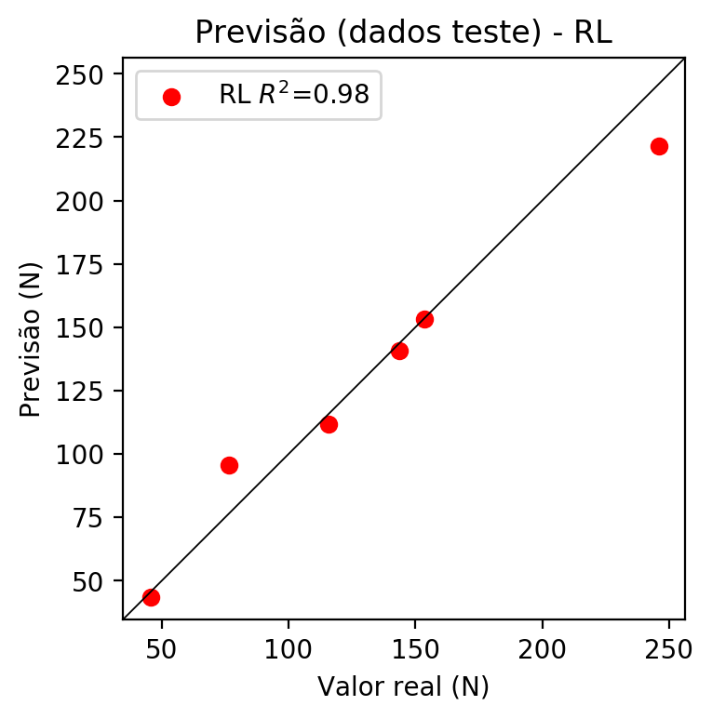

**Dados de treino**

* Erro relativo médio: 14.88
* Coeficiente de correlação: 0.95
* Coeficiente de determinação: 0.9
* MSE: 526.73
* RMSE: 22.95

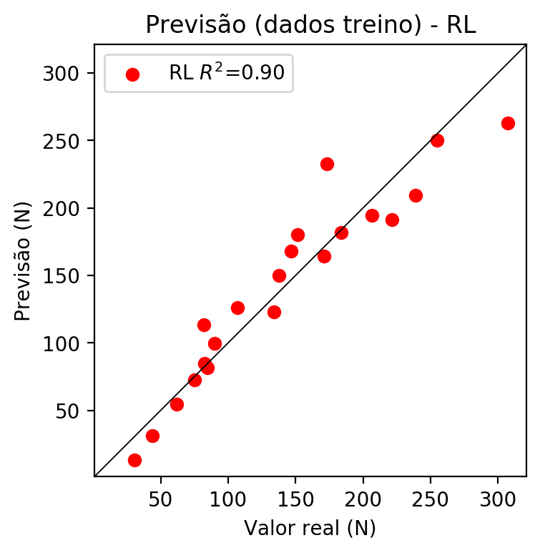

# RP2

# Coeficientes

[ 0. -0.20783923 0.47709884 0.85507614 -0.02489695 -0.17205103  
 -0.09652715 -0.26867163 0.1157648 -0.10339469]

# Erros

**Dados de teste**

* Erro relativo médio: 26.96
* Coeficiente de correlação: 0.98
* Coeficiente de determinação: 0.95
* MSE: 599.82
* RMSE: 24.49

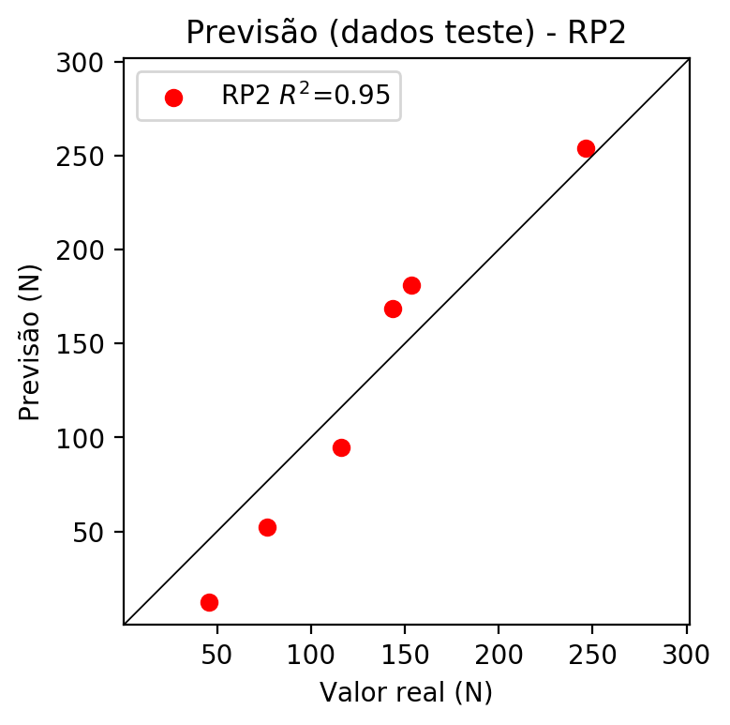

**Dados de treino**

* Erro relativo médio: 8.44
* Coeficiente de correlação: 0.98
* Coeficiente de determinação: 0.97
* MSE: 174.23
* RMSE: 13.2

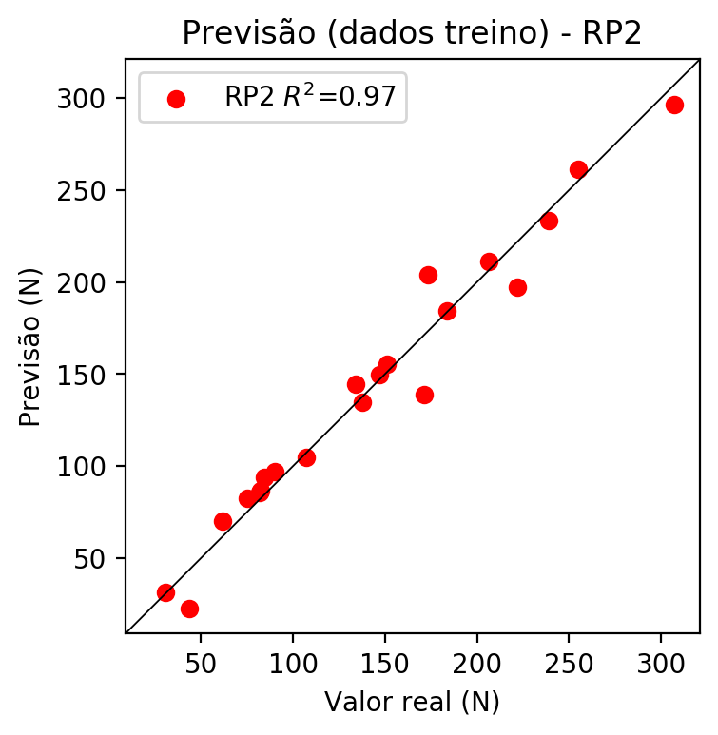

# RP3

# Coeficientes

[ 0. -0.04766753 0.17603269 0.3292042 0.05472413 -0.09470094  
 -0.09479055 -0.20717997 0.12920759 -0.00860206 -0.0688531 0.02246785  
 -0.03287088 -0.01723955 -0.15552551 -0.07265117 0.25426944 -0.19340764  
 -0.1006366 0.47551718]

# Erros

**Dados de teste**

* Erro relativo médio: 23.49
* Coeficiente de correlação: 0.97
* Coeficiente de determinação: 0.93
* MSE: 490.87
* RMSE: 22.16

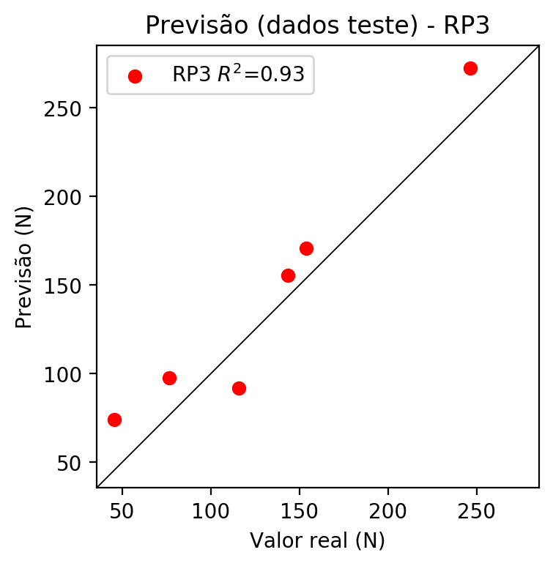

**Dados de treino**

* Erro relativo médio: 4.23
* Coeficiente de correlação: 1.0
* Coeficiente de determinação: 0.99
* MSE: 34.97
* RMSE: 5.91

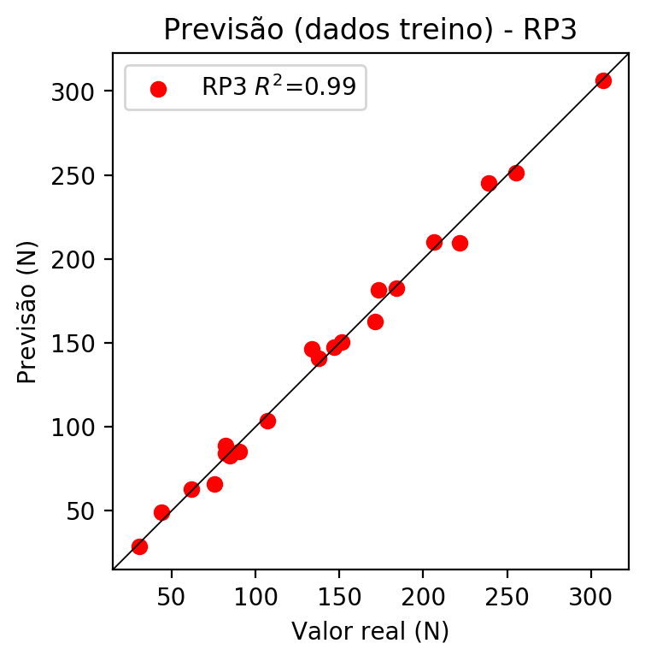

# RP4

# Coeficientes

[ 5.55111512e-17 1.66513654e-03 1.68565119e-01 3.02326395e-01  
 -1.01718538e-02 -3.66487154e-02 -2.09797794e-02 -2.20569175e-03  
 3.04992419e-02 5.75641998e-02 2.40519723e-03 9.77599553e-02  
 -1.67456120e-05 -3.57647757e-02 -7.95079846e-02 -9.60006190e-02  
 2.43482950e-01 -1.21553127e-01 -8.68324472e-02 4.36693682e-01  
 -1.43431726e-02 -1.75559233e-02 3.31529139e-02 -3.11646856e-03  
 -8.64353305e-02 1.27474911e-02 -5.29370334e-02 -1.23782785e-01  
 -3.76108232e-02 -3.03041258e-02 -3.18599919e-03 4.40544605e-02  
 -1.66491176e-01 4.40544605e-02 8.31482886e-02]

# Erros

**Dados de teste**

* Erro relativo médio: 28.56
* Coeficiente de correlação: 0.95
* Coeficiente de determinação: 0.9
* MSE: 772.33
* RMSE: 27.79

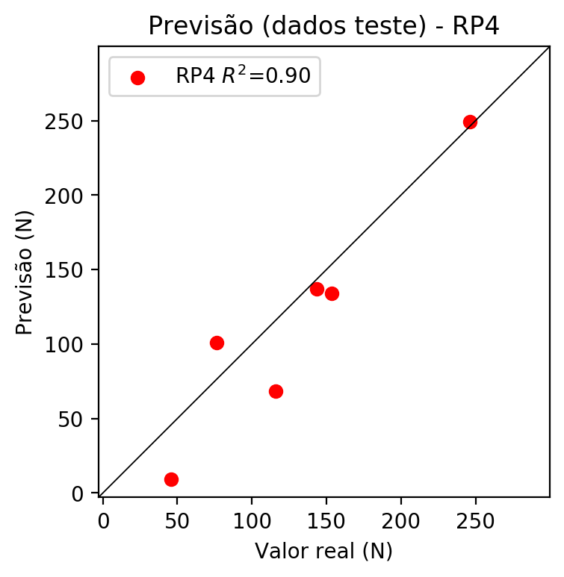

**Dados de treino**

* Erro relativo médio: 0.0
* Coeficiente de correlação: 1.0
* Coeficiente de determinação: 1.0
* MSE: 0.0
* RMSE: 0.0

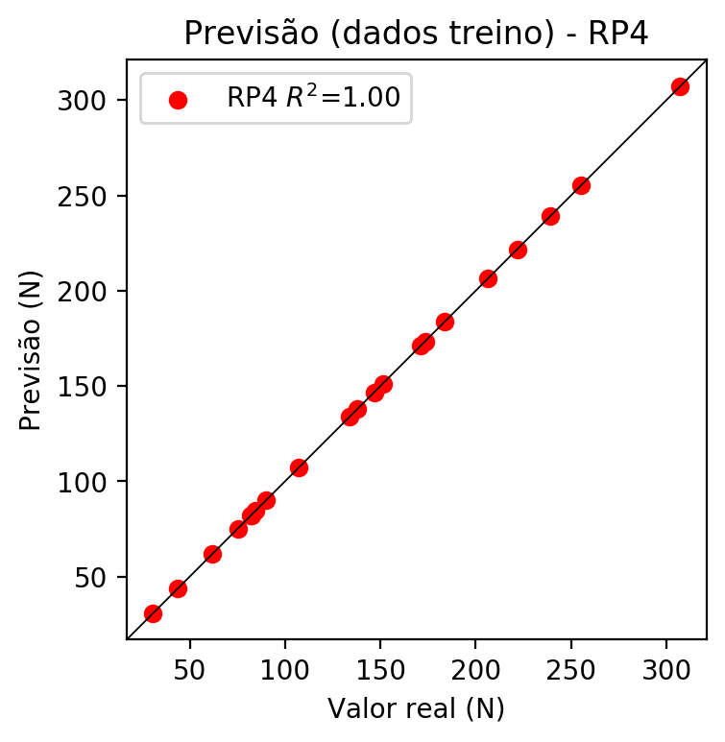

# Geral

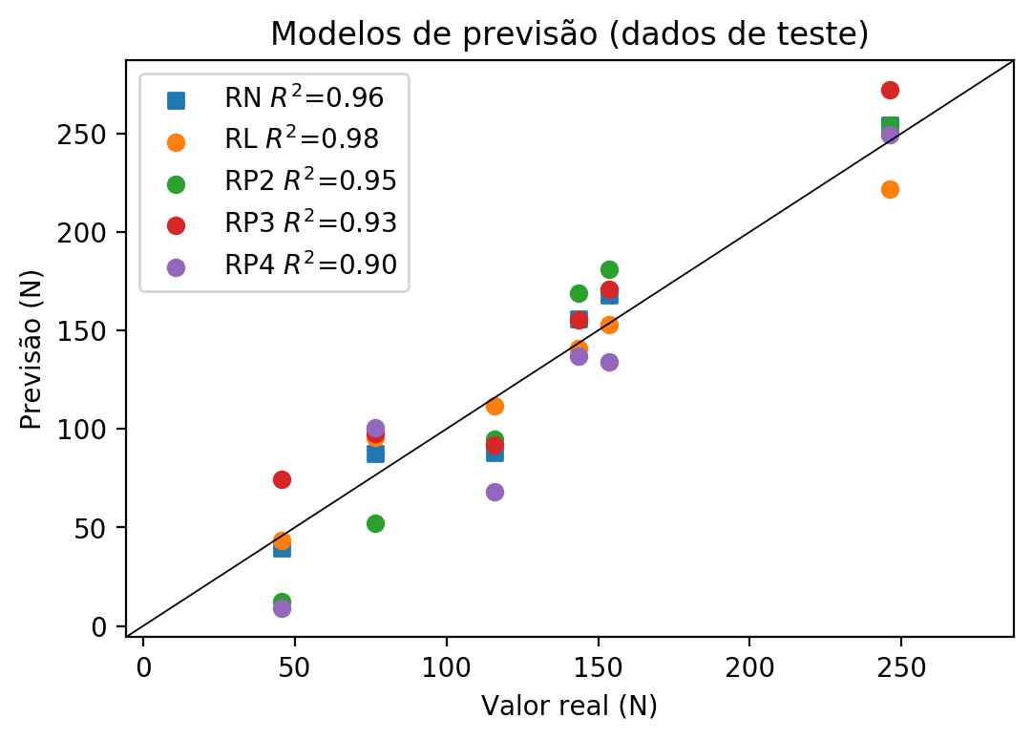

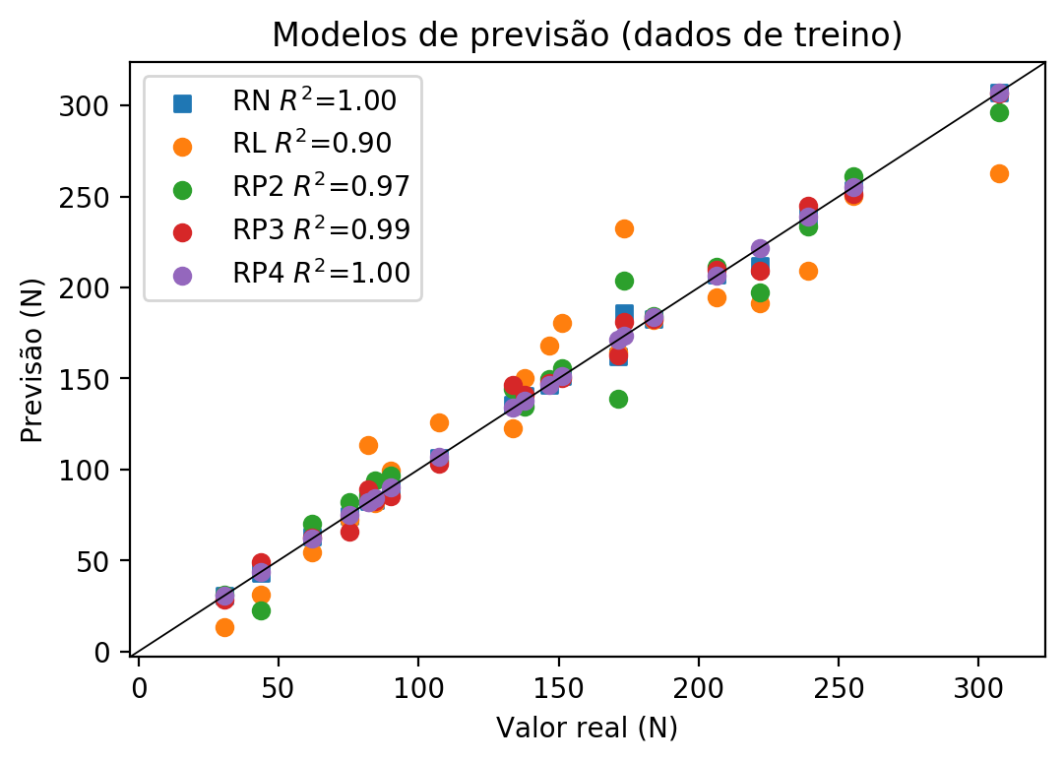

**Dados de teste**

|  |  |  |  |  |  |  |  |  |  |  |
| --- | --- | --- | --- | --- | --- | --- | --- | --- | --- | --- |
| Valor real | RN Previsto | RN Erro (%) | RL Previsto | RL Erro (%) | RP2 Previsto | RP2 Erro (%) | RP3 Previsto | RP3 Erro (%) | RP4 Previsto | RP4 Erro (%) |
| 45.58 | 39.44 | 13.47 | 43.48 | 4.61 | 12.23 | 73.17 | 74.32 | 63.05 | 9.01 | 80.23 |
| 246.17 | 254.39 | 3.34 | 221.55 | 10.0 | 254.07 | 3.21 | 272.28 | 10.61 | 249.13 | 1.2 |
| 143.5 | 155.72 | 8.52 | 140.82 | 1.87 | 168.67 | 17.54 | 155.38 | 8.28 | 137.13 | 4.44 |
| 153.68 | 167.94 | 9.28 | 153.13 | 0.36 | 181.09 | 17.84 | 170.64 | 11.04 | 134.22 | 12.66 |
| 76.58 | 87.66 | 14.47 | 95.72 | 24.99 | 52.29 | 31.72 | 97.52 | 27.34 | 100.8 | 31.63 |
| 115.93 | 87.76 | 24.3 | 111.9 | 3.48 | 94.73 | 18.29 | 92.05 | 20.6 | 68.16 | 41.21 |

**Dados de treino**

|  |  |  |  |  |  |  |  |  |  |  |
| --- | --- | --- | --- | --- | --- | --- | --- | --- | --- | --- |
| Valor real | RN Previsto | RN Erro (%) | RL Previsto | RL Erro (%) | RP2 Previsto | RP2 Erro (%) | RP3 Previsto | RP3 Erro (%) | RP4 Previsto | RP4 Erro (%) |
| 239.2 | 238.84 | 0.15 | 209.24 | 12.53 | 233.48 | 2.39 | 245.13 | 2.48 | 239.2 | 0.0 |
| 137.73 | 140.38 | 1.92 | 150.12 | 9.0 | 134.72 | 2.19 | 140.93 | 2.32 | 137.73 | 0.0 |
| 173.4 | 186.23 | 7.4 | 232.56 | 34.12 | 203.94 | 17.61 | 181.31 | 4.56 | 173.4 | 0.0 |
| 183.86 | 182.65 | 0.66 | 182.04 | 0.99 | 184.29 | 0.23 | 182.5 | 0.74 | 183.86 | 0.0 |
| 151.26 | 151.49 | 0.15 | 180.32 | 19.21 | 155.6 | 2.87 | 150.3 | 0.63 | 151.26 | 0.0 |
| 43.74 | 43.36 | 0.87 | 31.18 | 28.72 | 22.56 | 48.42 | 49.01 | 12.05 | 43.74 | 0.0 |
| 107.14 | 106.26 | 0.82 | 125.93 | 17.54 | 104.58 | 2.39 | 103.46 | 3.43 | 107.14 | 0.0 |
| 307.2 | 307.01 | 0.06 | 262.77 | 14.46 | 296.37 | 3.53 | 306.39 | 0.26 | 307.2 | 0.0 |
| 255.12 | 253.81 | 0.51 | 250.46 | 1.83 | 261.2 | 2.38 | 251.22 | 1.53 | 255.12 | 0.0 |
| 84.48 | 83.21 | 1.5 | 81.7 | 3.29 | 93.91 | 11.16 | 82.69 | 2.12 | 84.48 | 0.0 |
| 82.06 | 83.85 | 2.18 | 113.62 | 38.46 | 85.76 | 4.51 | 88.94 | 8.38 | 82.06 | 0.0 |
| 75.23 | 74.77 | 0.61 | 72.4 | 3.76 | 82.25 | 9.33 | 66.07 | 12.18 | 75.23 | 0.0 |
| 171.16 | 162.0 | 5.35 | 164.14 | 4.1 | 138.93 | 18.83 | 162.59 | 5.01 | 171.16 | 0.0 |
| 90.07 | 89.87 | 0.22 | 99.6 | 10.58 | 96.88 | 7.56 | 85.47 | 5.11 | 90.07 | 0.0 |
| 82.31 | 82.66 | 0.43 | 84.71 | 2.92 | 86.49 | 5.08 | 84.23 | 2.33 | 82.31 | 0.0 |
| 221.69 | 212.08 | 4.33 | 191.34 | 13.69 | 197.42 | 10.95 | 209.37 | 5.56 | 221.69 | 0.0 |
| 61.88 | 63.25 | 2.21 | 54.5 | 11.93 | 69.97 | 13.07 | 62.74 | 1.39 | 61.88 | 0.0 |
| 30.73 | 30.87 | 0.46 | 13.28 | 56.78 | 31.48 | 2.44 | 28.66 | 6.74 | 30.73 | 0.0 |
| 206.42 | 207.18 | 0.37 | 194.35 | 5.85 | 211.28 | 2.35 | 209.95 | 1.71 | 206.42 | 0.0 |
| 146.71 | 146.57 | 0.1 | 168.02 | 14.53 | 149.58 | 1.96 | 147.66 | 0.65 | 146.71 | 0.0 |
| 133.8 | 135.74 | 1.45 | 122.92 | 8.13 | 144.5 | 8.0 | 146.59 | 9.56 | 133.8 | 0.0 |